Олимпиада по истории: (Максимальное количество баллов = 40)
(Для учащихся с особыми образовательными возможностями
6 – 9 классы)
Ф.И.ребенка____________________________________ Дата рождения___________________
Ф.И.О. педагога _________________________________________________________________
Учреждение (полное название) _____________________________________________________
________________________________________________________________________________
E-mail педагога (родителя) ________________________________________________________
Почтовый адрес _________________________________________________________________
________________________________________________________________________________

Задания для обязательного выполнения:

- Какие знаменитые памятники архитектуры изображены на рисунках? Ответь по плану: (до 2 баллов)______

- Название;
- Автор;
- Год создания;
- Вес.
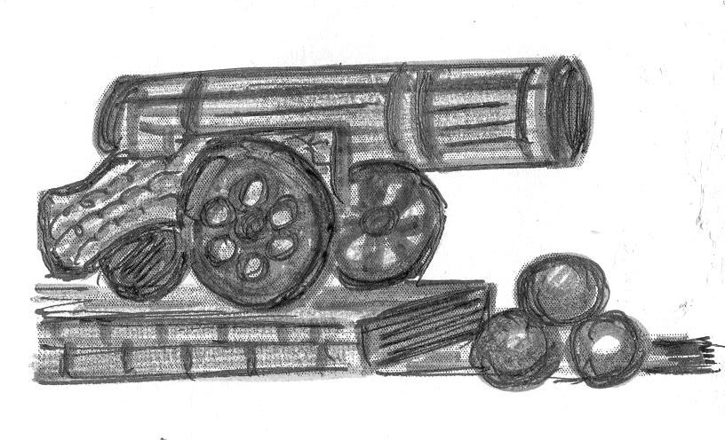  ...........................................................................  .......................................................................... ...........................................................................  .......................................................................... ............................................................................  .......................................................................... | 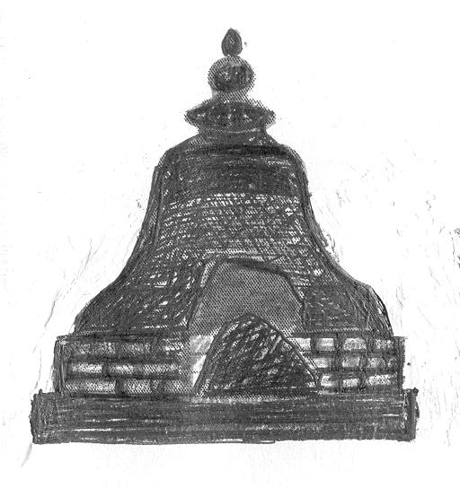  ...........................................................................  ........................................................................ ...........................................................................  ........................................................................ ...........................................................................  ...........................................................................

- Что в имени твоем? Напиши значения известных вам имен (до 2 баллов) _____

Александр – .......................................................  Андрей – .............................................................  Артём – ...............................................................  Виктор – ..............................................................  Георгий (Юрий) – ..............................................  Максим – ............................................................  Иван – .................................................................  Захар – .................................................................  Людмила – .......................................................... | Екатерина – ......................................................  Елена – .............................................................  Ирина – ...........................................................  Ольга – ............................................................  Софья – ............................................................  Виктор – ..........................................................  Марина – ..........................................................  Анна – ..............................................................  Виктор – ..........................................................

- Как возникли фамилии? Напиши по 5 фамилий по плану (до 2 баллов) _____

- Русские фамилии, которые произошли от имен.
...............................................................................................................................................................................................................................................................................................................
- Русские фамилии, образованные от занятий людей в далеком прошлом.
..............................................................................................................................................................................................................................................................................................................
- Русские фамилии от названия городов и рек.
..............................................................................................................................................................................................................................................................................................................
- Русские фамилии от названий животных.
..............................................................................................................................................................................................................................................................................................................
- Русские фамилии от названий птиц.
..............................................................................................................................................................................................................................................................................................................
- Русские фамилии от названий деревьев, цветов, трав.
..............................................................................................................................................................................................................................................................................................................

- Напиши названия месяцев из русского земледельческого календаря. Напиши по одной поговорке к каждому месяцу (до 3 баллов) _____

Месяц | Название в земледельческом календаре | Поговорки
...............................................  ...............................................  ...............................................  ...............................................  ...............................................  ...............................................  ...............................................  ...............................................  ...............................................  ...............................................  ...............................................  ............................................... | Перезимье,  просинец | ...............................................  ...............................................  ...............................................  ...............................................  ...............................................  ...............................................  ...............................................  ...............................................  ...............................................  ...............................................  ...............................................  ...............................................  ...............................................  ...............................................  ...............................................  ...............................................  ...............................................  ...............................................  ...............................................  ...............................................  ...............................................  ...............................................  ...............................................  ...............................................
Снежень,
бокогрей
Березень,
протальник
Берёзозол,
снегогон
 | Травник
 | Хлеборост
Страдник,
макушка лета
Жнивень,
разносол
Хмурень,
ревун
Листопад,
грязник
Полузимник,
трудень
Студень,
стужало

- Как зарождалась письменность? Что обозначили эти знаки в древности? Напиши (до 3 баллов) _____
 |  |  | 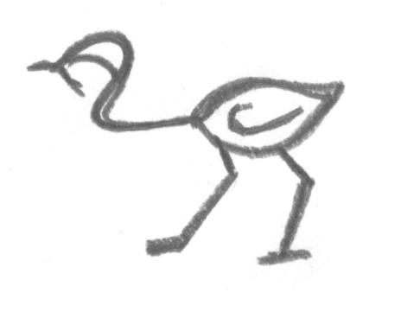 | 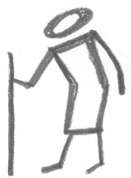
........................... | ............................. | ........................... | ............................ | .............................

- Что в древности обозначали данные слова? Напиши. Нарисуй (до 4 баллов) _____

Кокошник – ....................................................  ............................................................................  ............................................................................ | Частокол – ......................................................  ............................................................................  ............................................................................
Ухват – .............................................................  ............................................................................  ............................................................................ | Рогатина – .......................................................  ............................................................................  ............................................................................
Туесок – ..........................................................  ............................................................................  ............................................................................ | Булава – ...........................................................  ............................................................................  ............................................................................

- Составь родословную своей семьи (до 3 баллов) ______

Я

...........................................................................................................................................................
...........................................................................................................................................................

- Составь и нарисуй герб своего рода. Опиши, что он обозначает (до 4 баллов) _____
Герб – символ рода, города или государства.
Род – объединение родственников.

Герб семьи – ................................................... | Описание герба семьи – ...............................  ............................................................................  ............................................................................  ...........................................................................  ............................................................................  ............................................................................  ............................................................................  ...........................................................................  ............................................................................  ............................................................................  ............................................................................  ...........................................................................  ............................................................................  ............................................................................  ............................................................................  ...........................................................................  ............................................................................  ............................................................................  ............................................................................  ...........................................................................  ............................................................................
- Где и кода появились народные ремесла: дымковская игрушка, гжель, берестяная резьба, хохломская роспись, русские матрешки. Подпиши народные промыслы, дай краткую характеристику: когда и где зародились эти народные промыслы (до 4 баллов) ______

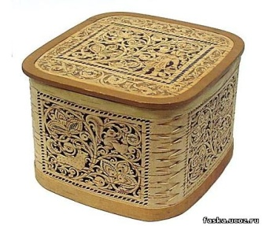 |  | 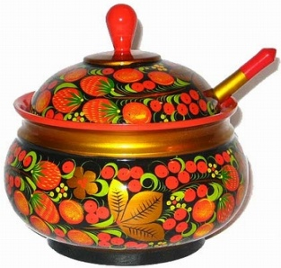 |  | 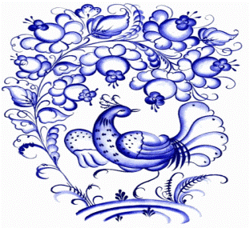
..................................................  ..................................................  ..................................................  ..................................................  ..................................................  ..................................................  ..................................................  ..................................................  .................................................. ..................................................  ..................................................  .................................................. |  | ..................................................  ..................................................  ..................................................  ..................................................  ..................................................  ..................................................  ..................................................  ..................................................  .................................................. ..................................................  ..................................................  ................................................. |  | ..................................................  ..................................................  ..................................................  ..................................................  ..................................................  ..................................................  ..................................................  ..................................................  .................................................. ..................................................  ..................................................  ..................................................
 | 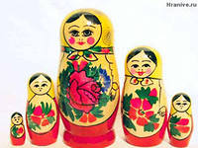 |  | 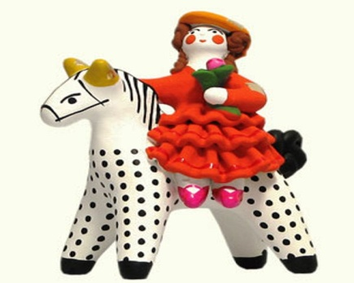
 | ................................................................  ................................................................  ................................................................  ................................................................  ................................................................  ................................................................  ................................................................  ................................................................  ................................................................  ................................................................  ................................................................  ................................................................ |  | ................................................................  ................................................................  ................................................................  ................................................................  ................................................................  ................................................................  ................................................................  ................................................................  ................................................................  ................................................................  ................................................................  ................................................................

Задания повышенной трудности (на усмотрение педагога):

- Как назывались старинные русские монеты? (до 5 баллов)______
............................................................................................................................................................................................................................................................................................................................................................................................................................................................................................................................................................................................................................................
- Как произошло слово рубль? (до 2 баллов) _____
............................................................................................................................................................................................................................................................................................................................................................................................................................................................................................................................................................................................................................................

- На рисунках изображены старинные монеты. Как они назывались? Подпиши (до 5 баллов) _____

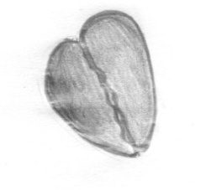 | 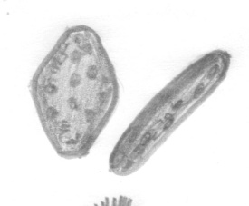 | 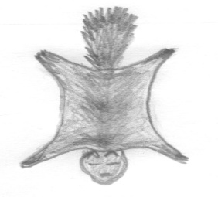
...............................................  ............................................... | ...............................................  ............................................... | ....................................................  ....................................................
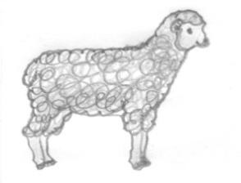 | 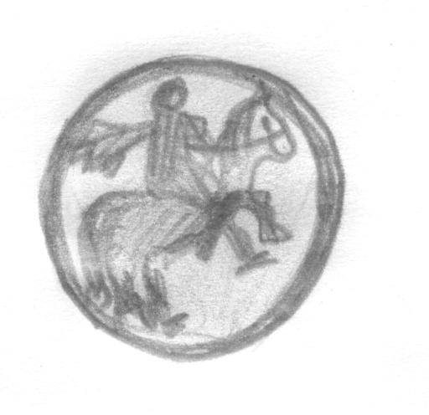 | 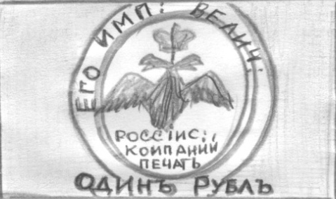
...............................................  ............................................... | ...............................................  ............................................... | ....................................................  ....................................................

- Посмотри на исторические даты, какие события они ознаменовали (до 5 баллов) _____
Дата | Событие
1564 год .........................................................................................................................................
1581 год ..........................................................................................................................................
1613 год ..........................................................................................................................................
1703 год ..........................................................................................................................................
1709 год ..........................................................................................................................................
1773 – 1775 годы ...........................................................................................................................
24.06.1812 – 12. 1812 г...................................................................................................................
26 августа 1812 год ........................................................................................................................
19 февраля 1861 года .....................................................................................................................
1897 год ..........................................................................................................................................
1894 год ..........................................................................................................................................
1905 – 1907 годы............................................................................................................................
1914 год...........................................................................................................................................
2 марта 1917 год............................................................................................................................
октябрь 1917 год............................................................................................................................
1918 – 1922 годы............................................................................................................................
30 декабря 1922 года......................................................................................................................
1 сентября 1939 года......................................................................................................................
1941 – 1945 годы............................................................................................................................
9 мая 1945 года...............................................................................................................................
12 апреля 1961 года........................................................................................................................
1979 – 1989 годы............................................................................................................................
1990 год .........................................................................................................................................
12 июня 1990 года .........................................................................................................................
Количество баллов:

1 | 2 | 3 | 4 | 5 | 6 | 7 | 8 | 9 | 10 | 11 | 12 | Всего

